Smart Wind Energy Forecast
Weather-Based Prediction of Wind Turbine Energy

By
TANUJA MALLIPAMU (23P35A0411, Aditya College of Engineering and Technology - Surampalem)
Raamya Thumathi (22MH1A0573, Aditya college of engineering -Surampalem)

Date
February, 2026

Contents
1. Abstract 1
2. Introduction 2
3. Objective 3
4. Dataset 4
5. Methodology – Preprocessing 5
6. Model Architecture 6
7. Results and Evaluation 7
8. Applications 8
9. Flask Deployment 9-10
10. Conclusion 11
11. Future Work 12
12. References 13

ABSTRACT

Accurate prediction of wind turbine energy output plays a crucial role in efficient renewable energy management and grid stability. In this project, we propose a machine learning–based system for predicting wind turbine power output using historical turbine data and live weather inputs. A Random Forest regression model is employed due to its robustness and ability to handle non-linear relationships between features. The model is trained on a publicly available wind turbine dataset and evaluated using standard regression metrics such as R² score, MAE, and RMSE.

To make the system practical and user-friendly, the trained model is integrated into a Flask-based web application. The application also connects to the OpenWeather API to fetch real-time weather data, enabling users to perform live predictions. Experimental results show that the model achieves good predictive performance with an R² score of approximately 0.87, demonstrating its suitability for real-world wind energy forecasting applications.

INTRODUCTION
Wind energy is one of the most important renewable energy sources in modern power systems. However, the power generated by wind turbines is highly dependent on weather conditions, especially wind speed, making accurate forecasting a challenging task. Traditional forecasting methods often fail to capture complex non-linear relationships present in real-world data.
With the advancement of machine learning techniques, data-driven models have become effective tools for predicting wind energy output. In this project, we develop a machine learning–based system that predicts wind turbine power output using historical turbine data and real-time weather information. The system also provides a web-based interface for easy interaction and visualization, making it suitable for practical use by energy analysts and operators.

OBJECTIVE
The main objective of this project is to design and implement an intelligent system that can accurately predict wind turbine energy output. The specific goals include:
- Developing a regression-based machine learning model for wind power prediction
- Achieving good prediction accuracy using historical turbine data
- Integrating live weather data for real-time forecasting
- Building a user-friendly web application using Flask
- Providing visual feedback for better interpretation of results

DATASET

The dataset used in this project is a wind turbine dataset containing historical records of turbine operation. It includes features such as:

Wind Speed (m/s)

Theoretical Power Curve (kWh)

LV Active Power (kW) (target output)

The dataset is stored in CSV format (T1.csv). It contains a large number of samples representing different operating conditions of a wind turbine. The data is suitable for supervised learning and is divided into training and testing sets using an 80:20 split. This dataset provides sufficient variability to train and evaluate a regression model effectively.
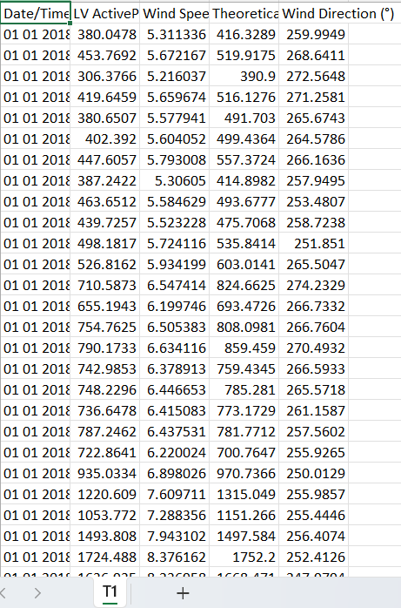

METHODOLOGY – PREPROCESSING

Before training the machine learning model, the dataset undergoes several preprocessing steps to improve model performance:

Data Cleaning: Removal of missing or inconsistent values from the dataset.

Feature Selection: Two main input features are selected: Wind Speed and Theoretical Power Curve.

Scaling: Feature scaling is performed using StandardScaler to normalize the input values and improve model convergence.

Train-Test Split: The dataset is split into 80% training data and 20% testing data for evaluation purposes.

These preprocessing steps ensure that the model receives clean and well-conditioned input data.

MODEL ARCHITECTURE

A Random Forest Regressor is used as the core prediction model in this project. Random Forest is an ensemble learning method that combines multiple decision trees to improve prediction accuracy and reduce overfitting.

Model Configuration:

Algorithm: Random Forest Regressor

Number of Trees (n_estimators): 150

Input Features:

Wind Speed (m/s)

Theoretical Power Curve (kWh)

Output:

LV Active Power (kW)

Training Strategy:

The model is trained on scaled training data.

Predictions are generated on the test dataset.

Performance is evaluated using regression metrics such as R², MAE, and RMSE.

The trained model and scaler are saved using Joblib for later use in the web application.
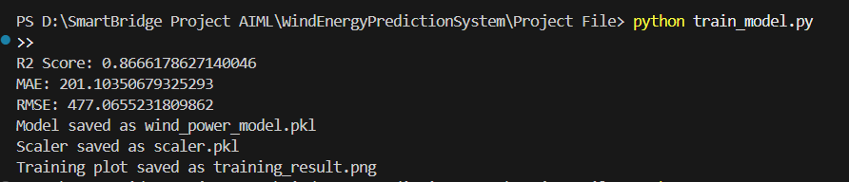

RESULTS AND EVALUATION

After training, the model is evaluated on the test dataset. The following performance metrics are obtained:

R² Score: 0.8666

Mean Absolute Error (MAE): 201.10

Root Mean Squared Error (RMSE): 477.07

The R² score of approximately 0.87 indicates that the model explains about 86.6% of the variance in wind power output, which shows good predictive performance.

A scatter plot of Actual vs Predicted Power Output is generated to visually analyze the model’s performance. The points show a strong positive correlation, indicating that the model predictions closely follow the actual values, with some expected deviations.
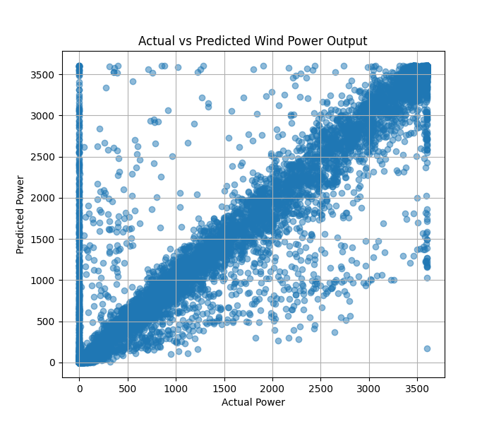

APPLICATIONS
The proposed system has several practical applications:
- Energy Forecasting: Helps in predicting wind energy output for better planning and scheduling.
- Grid Management: Assists grid operators in balancing supply and demand.
- Wind Farm Operations: Supports maintenance planning by analyzing expected power output.
- Educational Use: Can be used as a learning tool to demonstrate machine learning applications in renewable energy.

FLASK DEPLOYMENT

The trained model is deployed using a Flask web application to provide an interactive user interface.

System Flow:

The user selects a city or enters input parameters.

The application fetches live weather data using the OpenWeather API.

User inputs (wind speed and theoretical power) are processed and scaled.

The trained model predicts the power output.

The predicted result is displayed on the dashboard along with weather information.

Backend Components:

app.py: Flask application logic

train_model.py: Model training script

wind_power_model.pkl: Saved trained model

scaler.pkl: Saved scaler for preprocessing

Frontend Components:

HTML and CSS templates for the dashboard and landing page
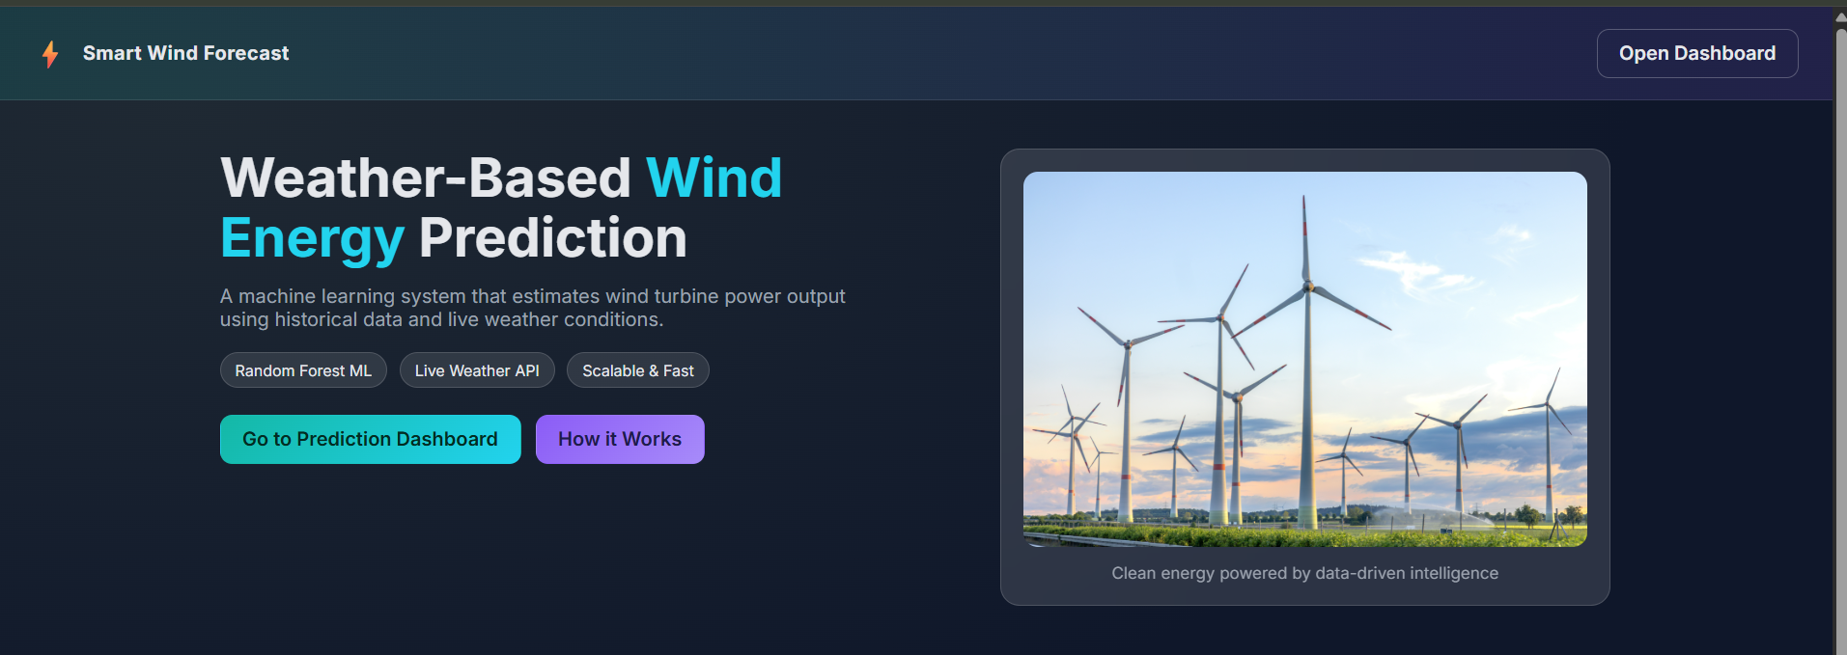

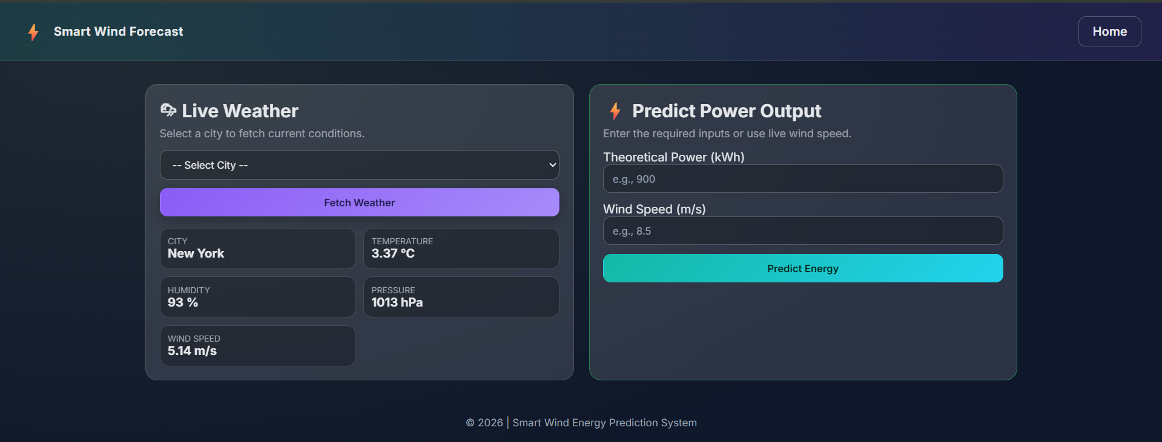
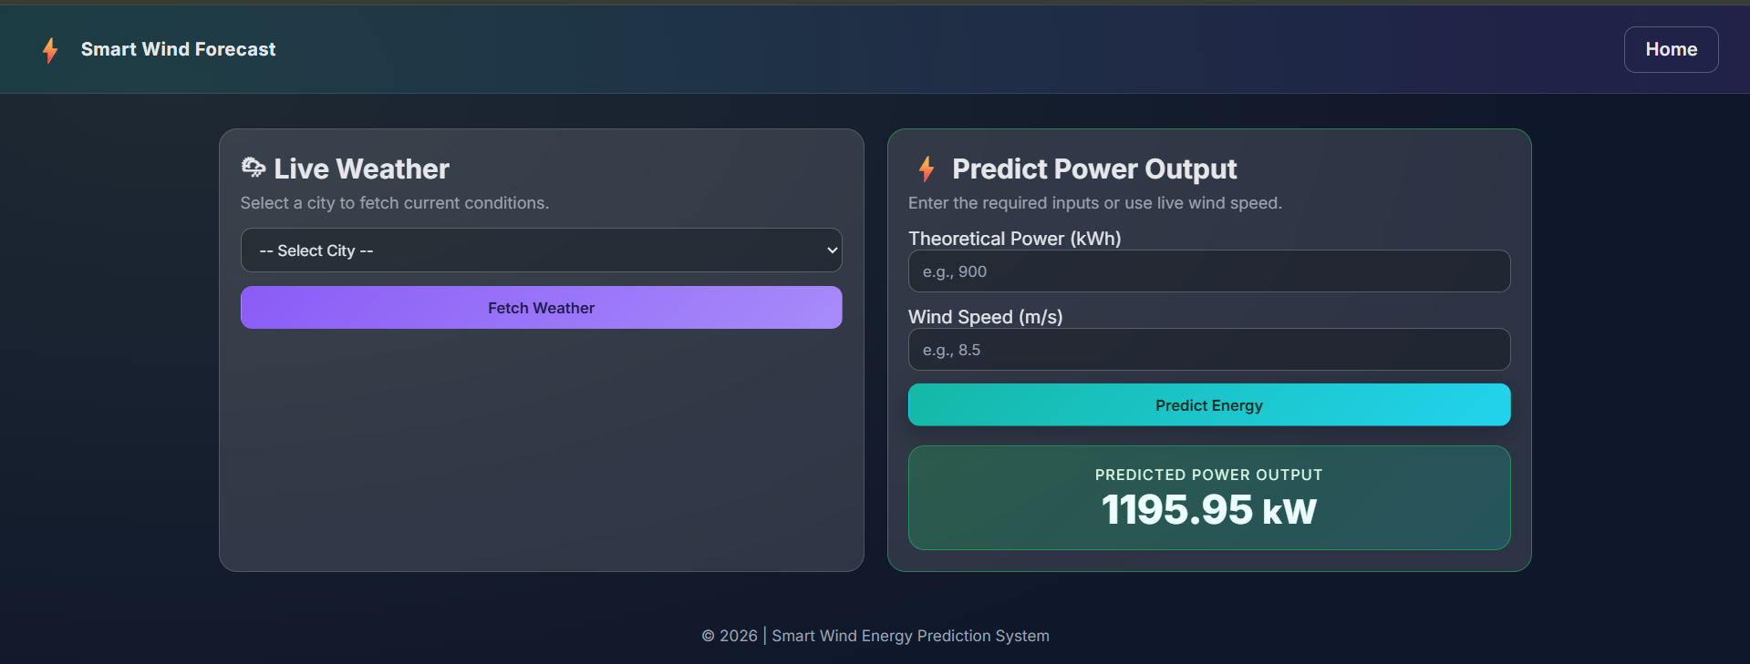

CONCLUSION
This project successfully demonstrates the application of machine learning techniques for predicting wind turbine energy output. By using a Random Forest regression model and proper data preprocessing, the system achieves good predictive accuracy with an R² score of approximately 0.87. The integration of a Flask-based web interface and live weather data makes the solution practical and user-friendly.
The proposed system can be effectively used in renewable energy forecasting, grid management, and decision support systems, providing a strong foundation for further improvements and real-world deployment.

FUTURE WORK

Future enhancements to this project may include:

Expanding the dataset to improve model generalization

Using advanced models such as Gradient Boosting or Deep Learning

Deploying the system on cloud platforms such as AWS or GCP

Adding user authentication and role-based access control

Integrating time-series forecasting for long-term energy prediction

Including more visualizations such as heatmaps and trend analysis

REFERENCES
[1] T. Hastie, R. Tibshirani, and J. Friedman, The Elements of Statistical Learning: Data Mining, Inference, and Prediction, 2nd ed., Springer, 2009.
[2] L. Breiman, “Random Forests,” Machine Learning, vol. 45, no. 1, pp. 5–32, 2001.
[3] F. Pedregosa et al., “Scikit-learn: Machine Learning in Python,” Journal of Machine Learning Research, vol. 12, pp. 2825–2830, 2011.
[4] OpenWeather, “OpenWeather API Documentation,” 2024. [Online]. Available: https://openweathermap.org/api
[5] Kaggle, “Wind Turbine Dataset,” Kaggle Datasets. [Online]. Available: https://www.kaggle.com/
[6] I. Goodfellow, Y. Bengio, and A. Courville, Deep Learning, MIT Press, 2016.
[7] J. Brownlee, Machine Learning Mastery with Python, Machine Learning Mastery, 2016.
[8] A. Géron, Hands-On Machine Learning with Scikit-Learn, Keras, and TensorFlow, 2nd ed., O’Reilly Media, 2019.
[9] Pal, S., and Mitra, P., “Case Studies on Application of Machine Learning in Renewable Energy Forecasting,” International Journal of Energy Research, 2020.
[10] Flask Documentation, “Flask Web Framework,” 2024. [Online]. Available: https://flask.palletsprojects.com/

